PROCESS FLOW DOCUMENT
Options Tracker — APIs, Cron Jobs, Data Flows & Automation
DiMarzio Personal Finance Platform

Version 1.0 | May 2026 | Confidential

1. System Overview
The Options Tracker is a full-stack personal options trading platform built on React/Vite (frontend), Vercel serverless functions (backend APIs), and Supabase (PostgreSQL database). It automates trade importing from Schwab and ETrade, manages covered call and cash-secured put strategies, and provides real-time market signals via SAGE scoring.

1.1 Technology Stack
- Frontend: React/Vite — deployed to Vercel, hosted at options-tracker-five.vercel.app
- Backend: Vercel serverless functions (Node.js) — 12 API files in /api/ folder
- Database: Supabase (PostgreSQL) — 36 tables, RLS enabled
- Brokers: Charles Schwab API (OAuth2) + E*Trade API (OAuth1)
- Notifications: Pushover push notifications to mobile
- ML/Simulation: DANI engine embedded in market-refresh.js

1.2 Deployment
- Production URL: https://options-tracker-five.vercel.app
- Git: Windows ThinkPad (Carbon), Git Bash, OneDrive, deploy via 'vercel --prod'
- Environment variables: VITE_SUPABASE_URL, VITE_SUPABASE_ANON_KEY, CRON_SECRET, ETRADE_CONSUMER_KEY, ETRADE_CONSUMER_SECRET, SCHWAB_CLIENT_ID, SCHWAB_CLIENT_SECRET, PUSHOVER_USER_KEY, PUSHOVER_API_TOKEN, APP_URL
- Vercel limit: 12 serverless functions in /api/ — consolidated where possible

1.3 Accounts
- Schwab accounts: Schwab 3866 (primary), additional accounts
- ETrade accounts: ETrade 6917 (primary), ETrade 8222 (secondary)
- Both Frank and his wife enter transactions — multi-device access required

2. API Files
All backend logic lives in /api/ on Vercel. Each file is a serverless function. The 12-file Vercel limit is a hard constraint — new functionality is added to existing files via action= routing.

2.1 API File Inventory

File | Trigger | Method | Actions | Key Notes
market-refresh.js | Vercel cron (every 5 min market hours) or manual ?force=1 | GET | Fetches quotes + chains from Schwab, computes SAGE scoring, fires auto-STO/BTC signals, writes price_snapshots, option_snapshots (trend features), iv_history, support_resistance. Also hosts DANI simulation engine via action= routing. | Central orchestration file. ~2,400 lines. Contains isMarketHours() gate. Writes ecosystem_heartbeat.
auto-import.js | Vercel cron (every 15 min) or manual trigger | GET | Fetches transactions from Schwab + ETrade, dedupes against existing contracts, inserts new STOs/BTOs/closes, handles partial fills, writes import_anomalies for exceptions. Fires Pushover on commit. | ETrade partial fill dedup via qty guard + DB unique constraint. Returns commitTx=true only on real inserts.
etrade.js | Manual auth trigger or internal calls | GET | OAuth1 flow for ETrade: action=auth (initiate), action=callback (token exchange), action=positions (fetch holdings), action=orders (fetch orders). Stores tokens in Supabase. | Consumer key/secret in Vercel env vars. Token re-auth required periodically via browser visit.
schwab-token-refresh.js | Vercel cron (hourly) or on-demand | GET | Refreshes Schwab OAuth2 access token using stored refresh token. Writes new tokens to Supabase. | Token stored in Supabase. Schwab tokens expire every 30 min. Cron keeps them fresh.
schwab-orders.js | Called by market-refresh or manual | GET/POST | Places and manages Schwab orders: action=preview-new, approve-new, preview, approve, status. Handles both standard and ETrade-routed order previews. | Order placement is gated by SAGE score and dry-run flag. All orders previewed before approval.
chain-refresh.js | Called by market-refresh or manual | GET | Fetches live option chain data for specific tickers. Used as a sub-call from market-refresh at signal-fire time for accurate pricing. | Originally separate from market-refresh to avoid stale data at signal time.
oi-tracker.js | Vercel cron (daily) or manual | GET | Fetches open interest snapshots for tracked tickers. Writes to oi_snapshots table. | Used for OI-based signal analysis.
schwab-auth.js | Manual or on first deploy | GET | Initiates Schwab OAuth2 flow. action=auth starts flow, action=callback exchanges code for tokens. | Consolidation pending — schwab-auth.js and schwab-token-refresh.js may merge.

Note on action= routing
market-refresh.js handles multiple actions via ?action= query param:
• Default (no action): full market refresh cycle
• action=simulate: run DANI simulation for one symbol
• action=simulateall: run all symbols with snapshot data
• action=status: snapshot coverage stats
• action=summary: sim_summary results for a symbol
• action=toppicks: best strategy per ticker ranked by EV

3. Cron Jobs
Cron jobs are configured in Vercel dashboard (no vercel.json). All are protected by CRON_SECRET header or query param. Market hours are approximately 9:30am–4:00pm ET Monday–Friday.

3.1 Cron Schedule

Job | Frequency | File | What It Does
Market Refresh | Every 5 min | market-refresh.js | Quotes, SAGE scoring, auto-STO/BTC signals, option chain snapshots, trend features, heartbeat
Auto Import | Every 15 min | auto-import.js | Pulls transactions from Schwab + ETrade, dedupes, inserts contracts, fires Pushover on new commits
Schwab Token Refresh | Every 60 min | schwab-token-refresh.js | Refreshes Schwab OAuth2 access token to prevent expiry
OI Tracker | Daily (market close) | oi-tracker.js | Captures open interest snapshots for tracked tickers

4. Market Refresh Flow (market-refresh.js)
The most complex process in the system. Runs every 5 minutes. Contains the full signal pipeline from quote fetch to order placement.

4.1 Full Process Flow

Step | Component | Action | Output | Notes
1 | Schwab Token | Validate/refresh OAuth2 token | Valid bearer token | Calls schwab-token-refresh if needed
2 | ETrade Token | Check ETrade token age | Token status log | Alerts if token from previous day — re-auth needed
3 | Quote Fetch | GET /marketdata/v1/quotes for all position tickers | quotes{} map | Includes VIX fetch for regime classification
4 | Daily Candles | GET /marketdata/v1/pricehistory for each ticker | dailyCandles{} map | Used for RSI, Bollinger, Fib, SMA, S/R computation
5 | Technical Analysis | Compute RSI, Bollinger, Fibonacci, S/R, IV rank | scoringData{} per ticker | Writes iv_history, support_resistance tables
6 | Price Snapshots | Write price + change% to price_snapshots | price_snapshots rows | 5-min intraday history
7 | Option Snapshots | Fetch live chains for all position tickers + RESEARCH_TICKERS, write 8 OTM + 8 ITM per side with trend features | option_snapshots rows | Feeds DANI simulation engine. No market hours gate.
8 | SAGE Scoring | Compute flag-based risk score per ticker from scoring_factors (DB-driven) | sage_flags, scoring_factor_values | Loads weights dynamically — no code deploy to adjust
9 | Signal Evaluation | Evaluate signal_rules against SAGE scores and price data | Candidate signals | Rules: Auto-STO, Auto-BTC, expiry day, momentum gates
10 | Auto-STO | For whitelisted tickers passing SAGE gate: find best OTM strike, preview order via schwab-orders | trade_orders row | Dry-run flag controls live vs simulated. Writes decision_log.
11 | Auto-BTC | For open contracts: check profit% against BTC threshold rules (e.g. 65% after 3pm) | BTC order or skip | Multiple rules: time-based, profit-based, expiry-based
12 | Order Status | Check status of any pending trade_orders | Updated order status | Fills committed to contracts table
13 | Push Notifications | Send Pushover for signals, fills, alerts, OKLO-style events | Pushover delivery | Includes deep links back to app
14 | Heartbeat | Write ok/error status to ecosystem_heartbeat | ecosystem_heartbeat row | Shared health monitoring across all agents

Figure 1: Market Refresh Process Flow
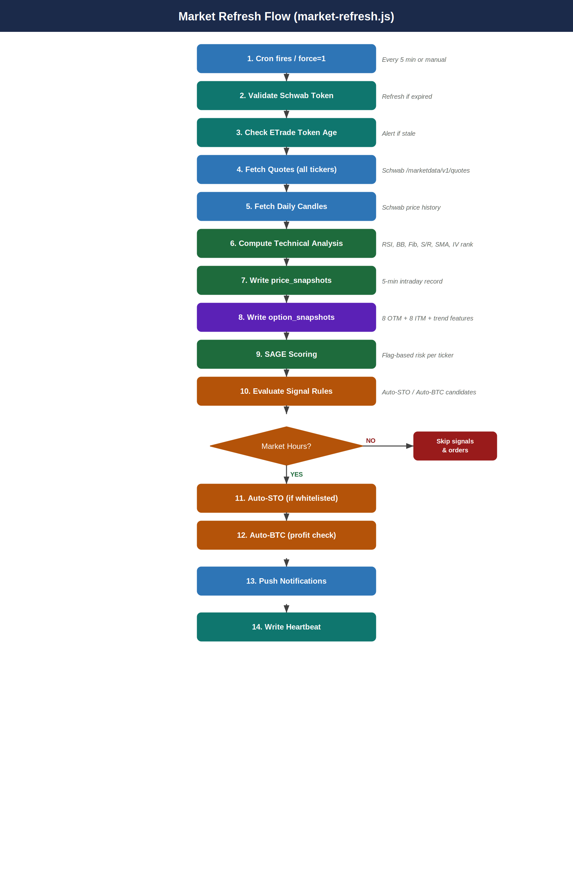
Market Hours Behavior
isMarketHours() = true (approx 9:30am–4:00pm ET Mon–Fri):
• Signal notifications fire
• Auto-STO / Auto-BTC evaluate and place orders
isMarketHours() = false (after hours, weekends):
• Quote fetch and snapshot writes still run (no gate)
• Signals computed but NOT notified
• Auto-STO / Auto-BTC skip order placement
force=1 query param bypasses all market hours checks

5. Auto-Import Flow (auto-import.js)
Runs every 15 minutes. Pulls transactions from both brokers, deduplicates against existing contracts, and commits new trades. The most complex dedup logic in the system due to ETrade's partial fill behavior.

5.1 Process Flow

Step | Component | Action | Output | Notes
1 | Schwab Fetch | GET Schwab transactions API for recent activity | schwabTxs[] | Uses transaction date filter to limit results
2 | ETrade Fetch | GET ETrade transactions for all accounts (6917, 8222) | etradeTxs[] | ETrade re-issues new transaction IDs daily for same trades
3 | Load Existing | Query contracts table for all existing schwab_transaction_ids | existingIds Set | Used for ID-based dedup (Schwab)
4 | Load Open Contracts | Query contracts with status=Open including status + schwab_transaction_id fields | openContracts[] | Used for partial fill merge and ETrade qty guard
5 | Load Fingerprints | Build fingerprint set from existing contracts | existingFingerprints Set | Normalized: stock|opt_type|strike|expires|account|premium_cents|qty|date_exec
6 | Filter Txs | Remove txs matching existing IDs or fingerprints | allTxs[] (filtered) | Also removes ETrade partials where existing.qty >= incoming.qty
7 | Commit Loop | For each new tx: match to open contract (closes) or insert (opens) | committed[], anomalies[] | Partial fill merge: if same position exists, update qty+premium
8 | Anomaly Write | Write unmatched/assigned/error txs to import_anomalies | import_anomalies rows | Types: assigned, unmatched_close, commit_error, duplicate
9 | Push Notification | If committed.length > 0: send Pushover with count and open/close breakdown | Pushover delivery | Only fires when commitTx returns true (real insert)
10 | Heartbeat | Write committed/anomaly counts to ecosystem_heartbeat | ecosystem_heartbeat row | status=ok always unless exception

Figure 2: Auto-Import Process Flow
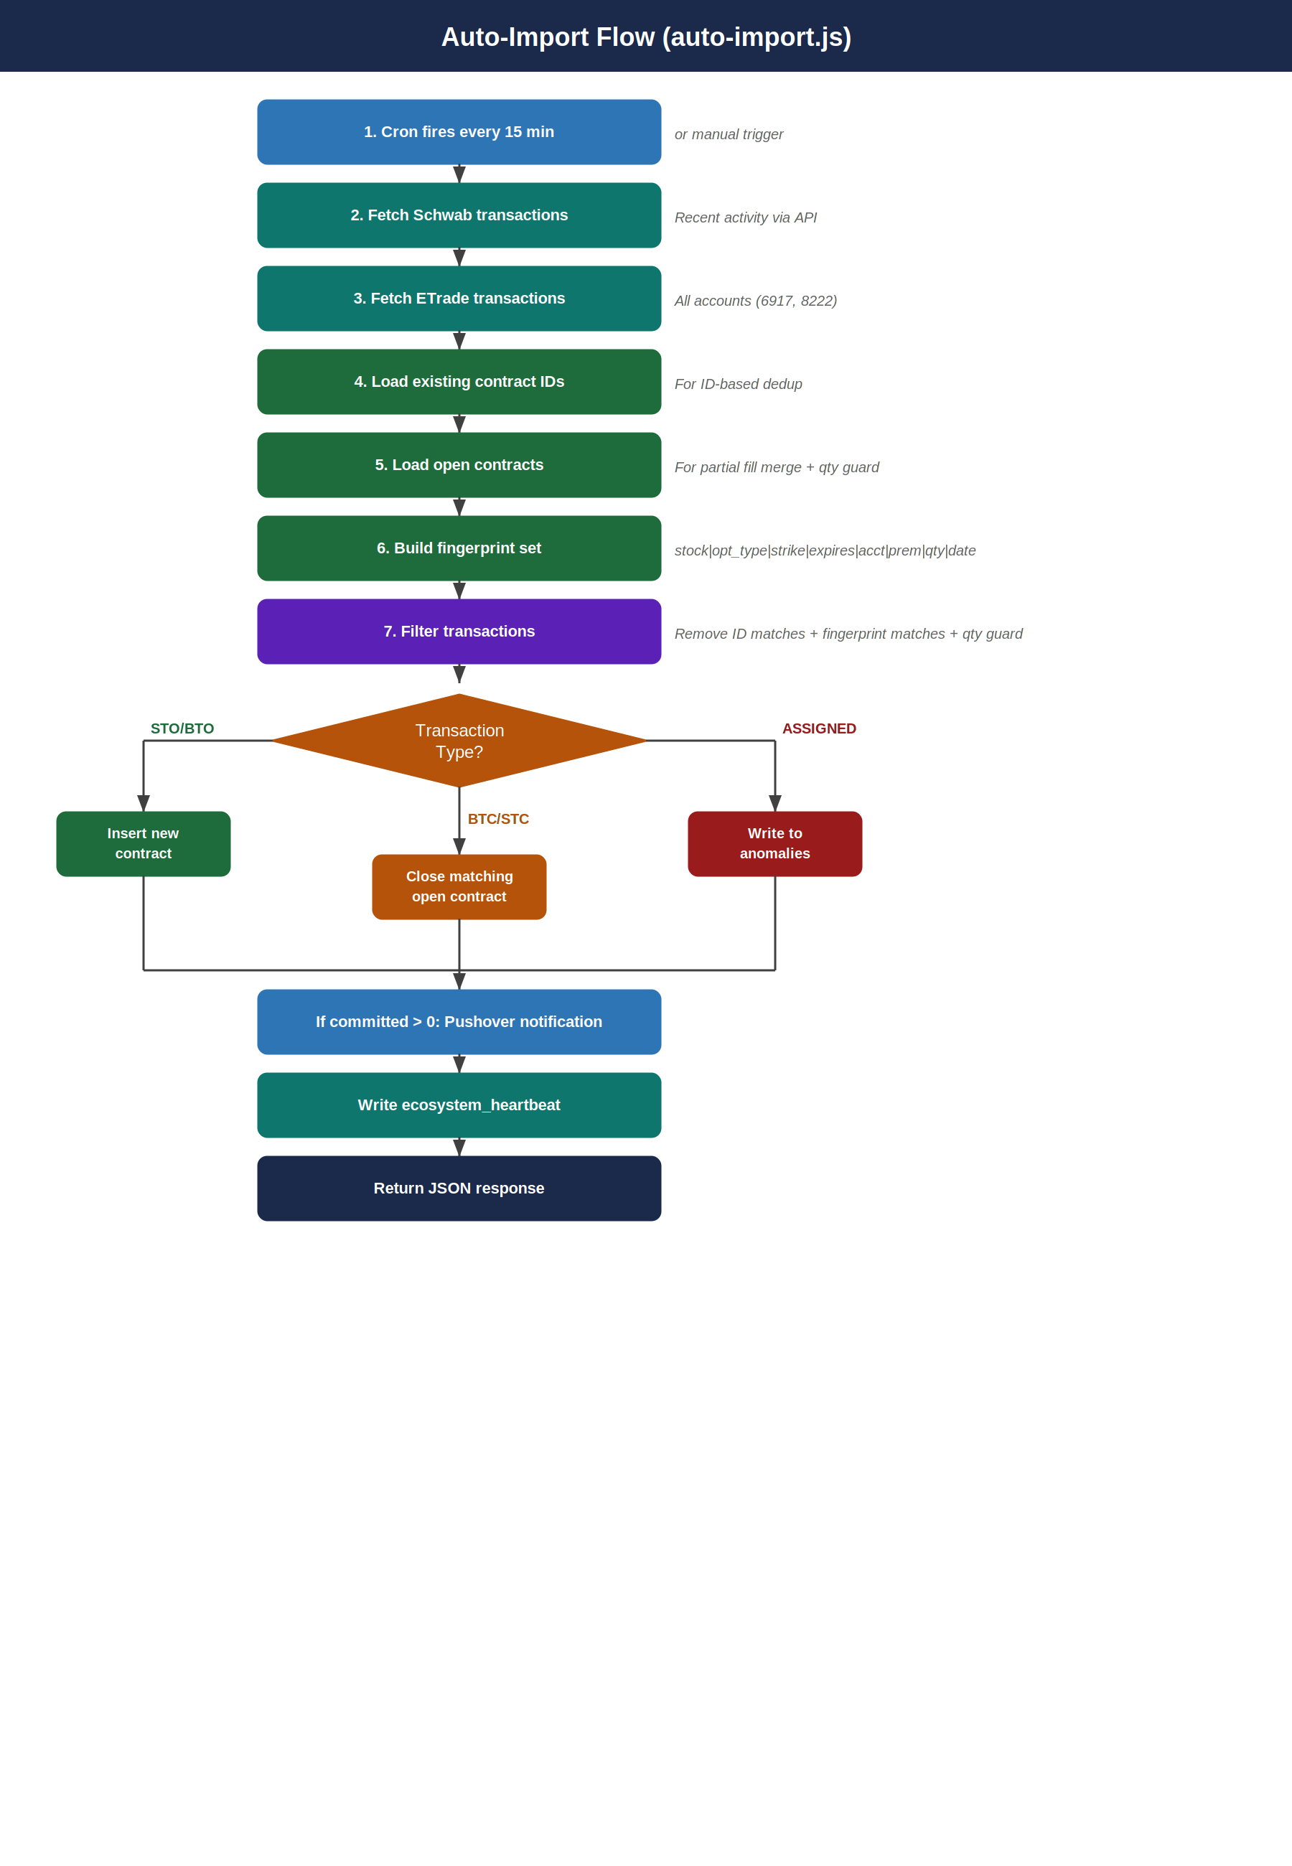

5.2 ETrade Partial Fill Dedup Logic
ETrade is the most complex dedup case. The same trade may appear as multiple partial fills with different transaction IDs on different days.
- ID check: etrade_XXXXXX IDs change daily — cannot rely on ID alone
- Fingerprint check: stock|opt_type|strike|expires|account|premium_cents|qty|date_exec — catches same-day duplicates
- Qty guard: if open contract exists for same position AND existing.qty >= incoming.qty — skip (re-issued partial)
- DB constraint: contracts_etrade_dedup unique index on (stock, opt_type, strike, expires, account, date_exec, qty) WHERE ETrade AND Open — last line of defense
- 23505 handling: unique constraint violations caught silently, not surfaced as anomalies

5.3 Assignment Handling
- ETrade 'Option Assigned' transactions detected by opt_type = 'ASSIGNED'
- Automatically routed to import_anomalies with anomaly_type = 'assigned'
- Requires manual resolution: close the STO contract in dashboard, verify shares in broker
- Stock holdings already captured in system — future automation will match assignment to position

6. SAGE Scoring Engine
SAGE (Scoring and Gating Engine) is the risk model that determines whether auto-STO should fire for a given ticker. It is fully DB-driven — no code deploy needed to adjust weights or thresholds.

6.1 Architecture
- Flag-based risk model — not a single score, but a set of boolean flags with severity levels
- Factors loaded from scoring_factors table at runtime — weights adjustable in DB
- Factor values written to scoring_factor_values per run per ticker
- Flags written to sage_flags when thresholds crossed
- Active flags written to sage_attention
- All decisions written to decision_log for full audit trail

6.2 Current Scoring Factors

Factor | Type | Signal | Notes
iv_rank | Market | High IV rank = good premium | Percentile rank of current IV vs 52-week range
iv_percentile | Market | High IV pct = expensive options | IV relative to historical distribution
fib_support | Technical | Price near Fib support = lower risk STO | 50%, 61.8% retracement levels
bb_pct_b | Technical | BB%B < 0.5 = price in lower band | Price position within Bollinger Bands
gap_flag | Technical | Gap up = negative signal (avoid STO) | Large overnight gap increases risk
sr_support | Technical | Price near S/R support | Swing high/low based support/resistance
ticker_tier | Profile | safe/watch/high_risk classification | hand-coded per ticker, stored in ticker_tiers
momentum | Price | Min change% gate per ticker | sto_momentum_config: skip if insufficient move

Future SAGE Improvements (DANI Phase 2+)
• Trend scoring: SMA alignment, RSI trend, price vs 50-day (data now collecting in option_snapshots)
• DANI-informed weights: sim_summary win rates auto-adjust scoring_weights
• XGBoost model replaces hand-tuned weights (Stage 3)
• SHAP explainability: every signal shows which features drove it

7. DANI Simulation Engine
DANI (Directional Analytics & Numerical Intelligence) is embedded in market-refresh.js. It collects real intraday option chain data and runs strategy simulations to find optimal parameters per ticker.

7.1 Data Collection
- Runs on every market-refresh cycle (no market hours gate)
- Fetches live chains for all position tickers + RESEARCH_TICKERS (e.g. GEV)
- Stores 8 OTM + 8 ITM strikes per side (call + put) per expiry
- Captures: bid, ask, mid, IV, delta, gamma, theta, vega, OI, volume, stock price
- Also captures trend features: VIX, SMA20/50/200, RSI14, SMA alignment, trend regime, day of week
- Purges data older than 90 days automatically

7.2 Simulation Parameters (1,440 Variants)

Parameter | Values | Rationale
OTM % | 1.0, 2.0, 2.5, 3.5 | Strike selection vs risk/reward tradeoff
Target % | 50, 65, 80 | % of premium to capture before closing
Stop % | 150, 200, 300 | % of premium lost before cutting loss
Entry Hour (ET) | 10, 11, 13 | Time of day for entry (10am, 11am, 1pm)
Max DTE | 2, 5 | Days to expiry at entry (weekly vs same-week)
Day of Week | Any, Mon, Tue, Wed, Thu | Does entry day affect win rate?
VIX Regime | Any, Low (<15), Normal (15-25), High (>25) | Does market volatility affect outcome?
Trend Regime | Any, Bullish, Neutral, Bearish | Does stock trend direction affect outcome?

7.3 Simulation Process
Step | Component | Action | Output | Notes
1 | Load Snapshots | Query option_snapshots for symbol over last N days | snapshots[] | Includes all trend feature columns
2 | Group by Day | Split snapshots into trading day buckets | byDay{} | Each day simulated independently
3 | Generate Combos | Build all 1,440 parameter combinations | combos[] | Cross product of all param grid values
4 | Sim Each Day | For each combo x day: find entry at target hour/OTM, track option price through subsequent snapshots, exit on target/stop/expiry | trade result | simDay() function
5 | Write sim_results | Batch insert all trade results (200 rows/chunk) | sim_results rows | Deletes old results for symbol first
6 | Compute Summary | Aggregate win rate, avg profit, avg loss, EV per combo | sim_summary rows | Upserted on (sim_label, symbol)
7 | Return Top 5 | Return top 5 combos by EV for quick feedback | API response | Filtered to combos with >= 5 trades

Figure 4: DANI Simulation Engine Flow
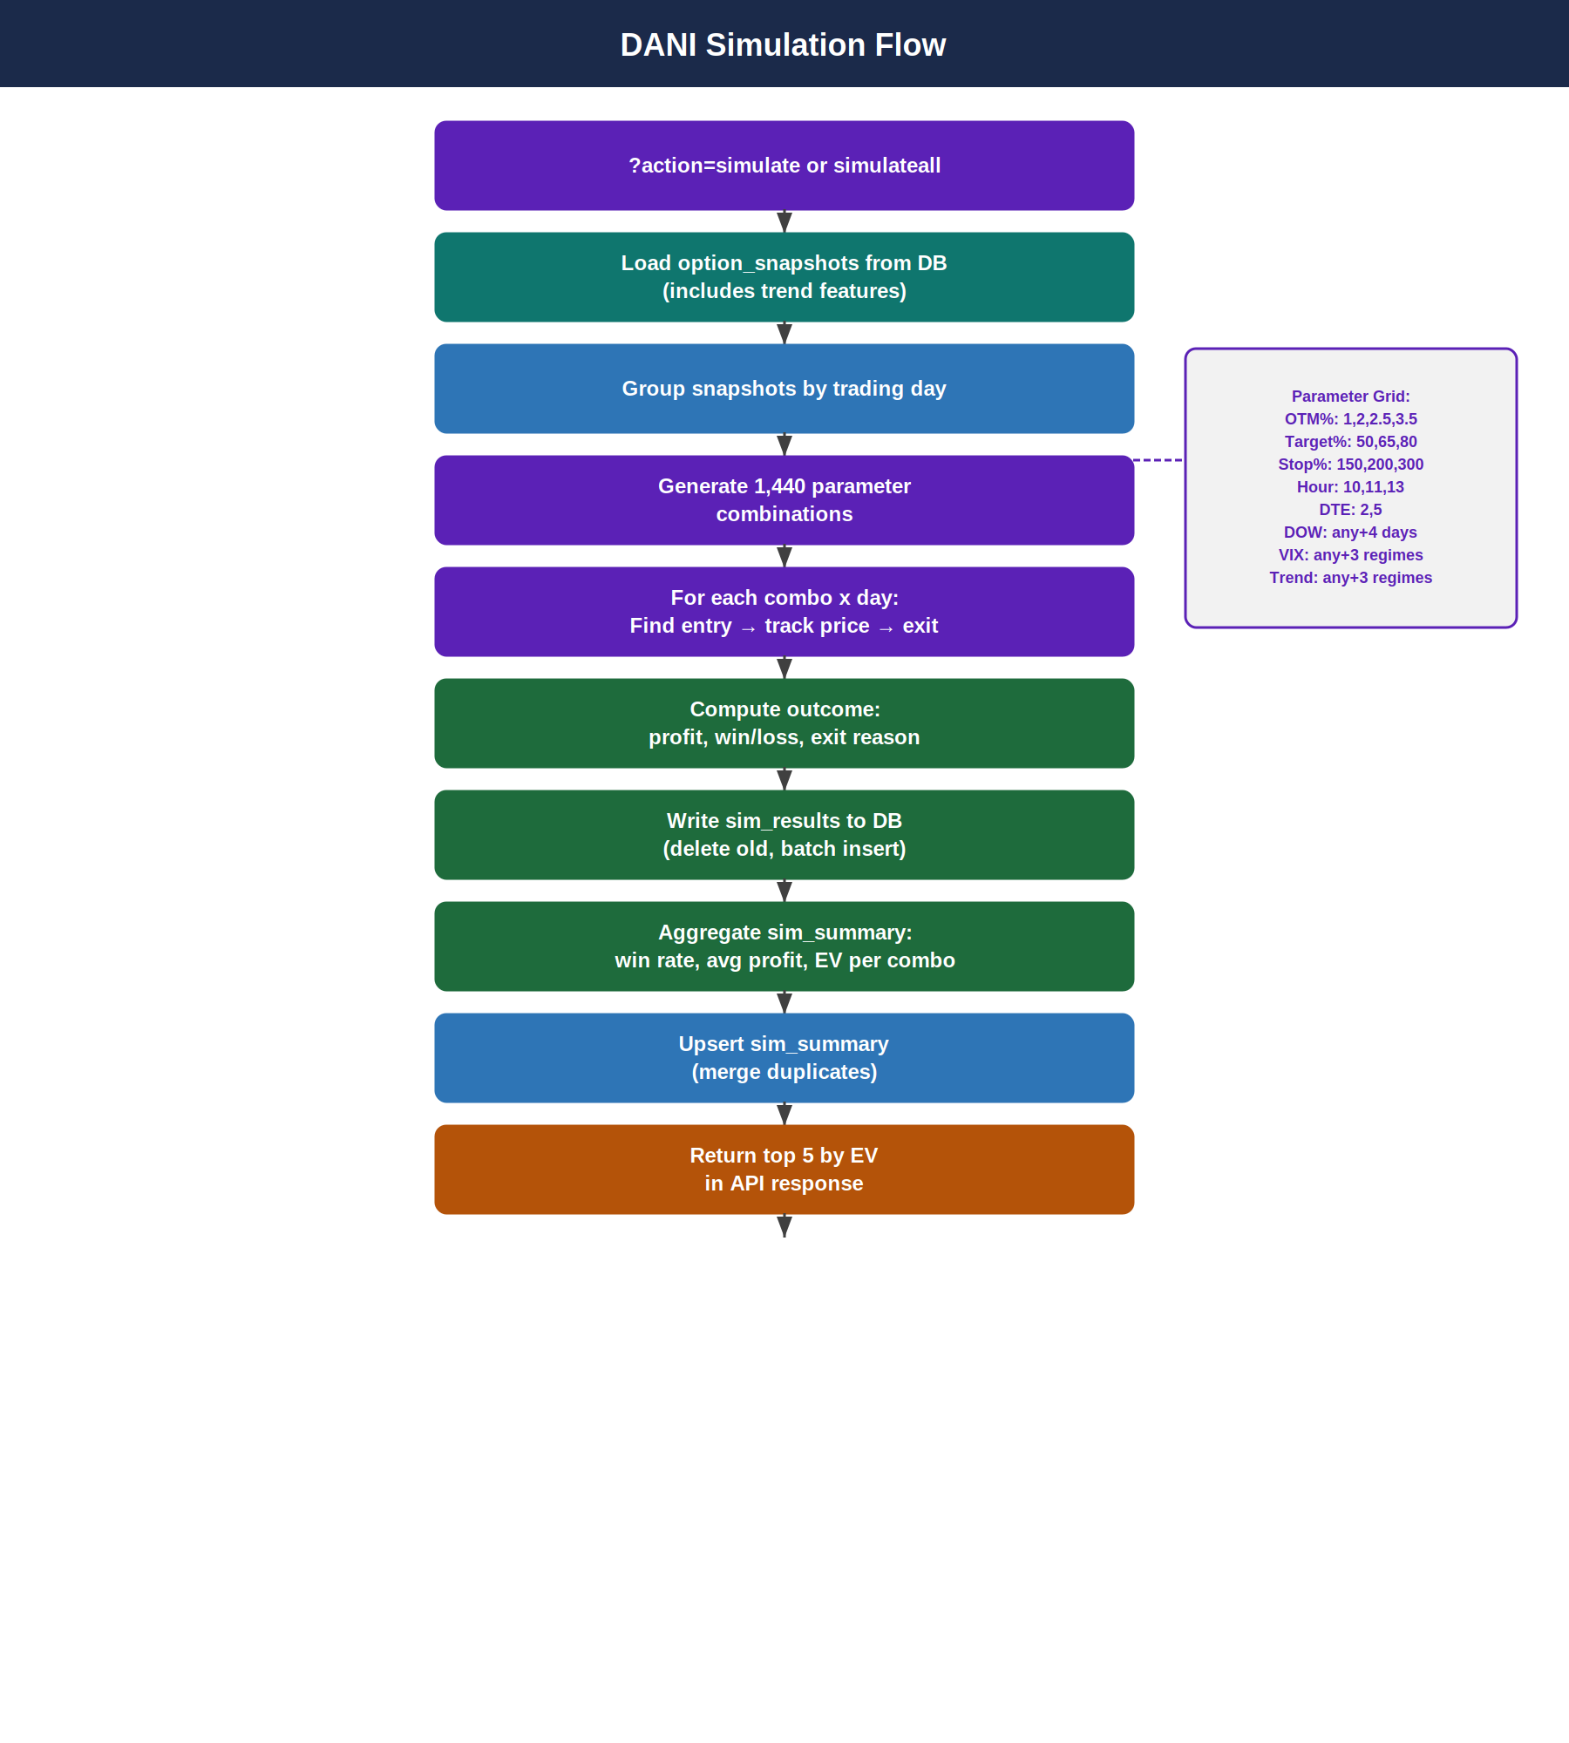

7.4 API Endpoints (via market-refresh.js)
- ?action=status — snapshot coverage per ticker (days collected)
- ?action=simulate&symbol=AAPL&days=30 — run one ticker
- ?action=simulateall&days=30 — run all tickers with >= 3 days data
- ?action=summary&symbol=AAPL — fetch sim_summary for UI
- ?action=toppicks — best strategy per ticker ranked by EV

8. ETrade OAuth Flow
ETrade uses OAuth 1.0a — more complex than Schwab's OAuth2. Tokens expire and require periodic re-authorization via browser.

Step | Component | Action | Output | Notes
1 | Initiate Auth | GET /api/etrade?action=auth | Redirect to ETrade login | Opens ETrade login page in browser
2 | User Login | User logs in on ETrade site | OAuth verifier code | ETrade redirects back to callback URL
3 | Callback | GET /api/etrade?action=callback&oauth_verifier=X | Access token stored in Supabase | Exchanges request token for access token
4 | Hourly Renew | Cron calls ETrade renew endpoint | Updated token in Supabase | Confirmed working — renews every hour
5 | Token Check | market-refresh checks token age on each run | Alert if token from previous day | Pushover alert: 'ETrade Re-Auth Required'
6 | Re-auth URL | https://options-tracker-five.vercel.app/api/etrade?action=auth&secret=X | Fresh OAuth flow | Must be done in browser, not curl

Figure 3: ETrade OAuth 1.0a Flow
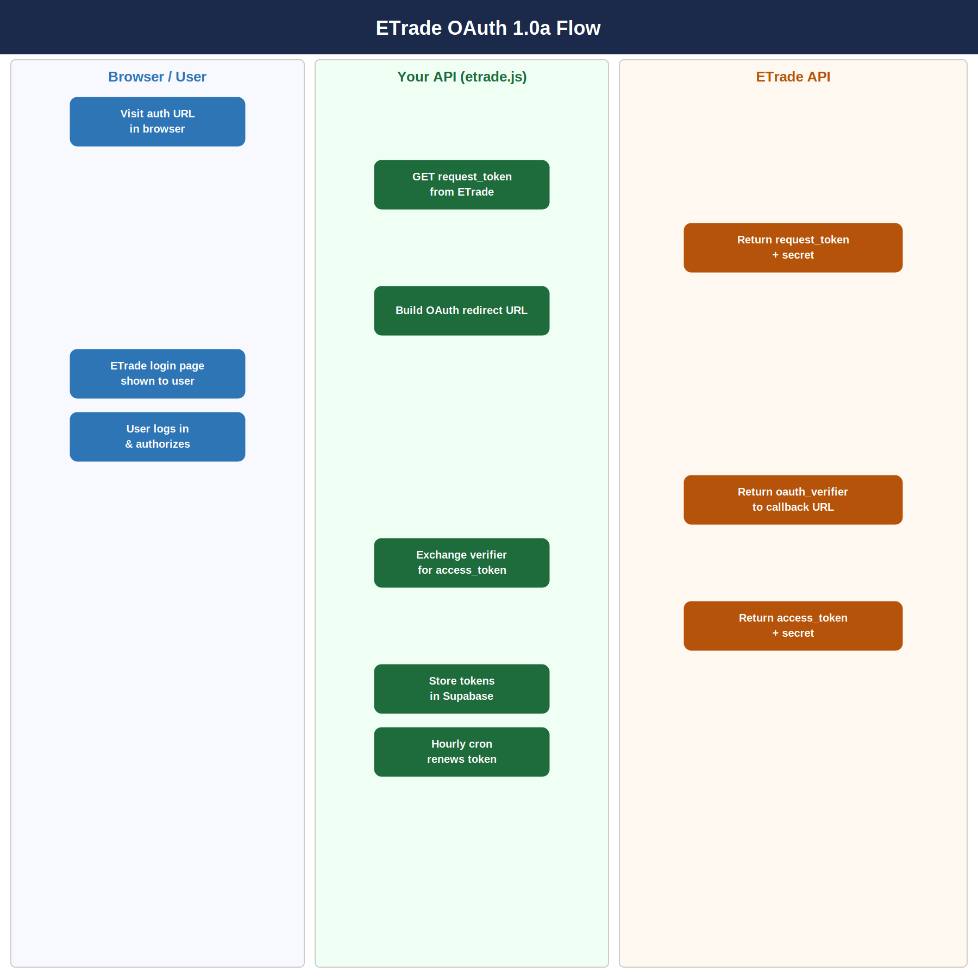
Common ETrade Issues
• signature_invalid: Consumer key/secret mismatch in Vercel env vars
• Token expired: Visit re-auth URL in browser to get fresh token
• New transaction IDs daily: Same trades re-appear with new IDs — handled by qty guard + fingerprint check
• Consumer credentials: Retrieved from developer.etrade.com — ETRADE_CONSUMER_KEY, ETRADE_CONSUMER_SECRET

9. Database Write Reference
Quick reference showing which process writes to which table.

9.1 Core Tables
Table | Owner | Written By | Purpose
contracts | Options Tracker | auto-import.js | One row per contract leg — central trading record
trade_orders | Options Tracker | market-refresh.js (schwab-orders) | Pending and historical order log
import_anomalies | Options Tracker | auto-import.js | Exceptions needing manual review
pending_transactions | Options Tracker | auto-import.js | Staging area before commit

9.2 Market Data Tables
Table | Owner | Written By | Purpose
price_snapshots | Market Data | market-refresh.js | 5-min intraday price + change% per ticker
option_snapshots | DANI | market-refresh.js | 5-min chain snapshots with Greeks + trend features
iv_history | Market Data | market-refresh.js | Daily IV rank/percentile per ticker
oi_snapshots | Market Data | oi-tracker.js | Daily open interest per strike
support_resistance | Market Data | market-refresh.js | Swing-based S/R levels
portfolio_snapshots | Market Data | market-refresh.js | Portfolio-level value snapshots

9.3 SAGE Tables
Table | Owner | Written By | Purpose
scoring_factors | SAGE | Manual (Supabase UI) | Factor definitions + weights — adjust here to change SAGE behavior
scoring_factor_values | SAGE | market-refresh.js | Per-ticker factor values written each run
scoring_weights | SAGE | Manual or DANI (future) | Current active weights
sage_flags | SAGE | market-refresh.js | Active risk flags per ticker
sage_attention | SAGE | market-refresh.js | Flag instances with timestamps
signal_log | SAGE | market-refresh.js | Every signal evaluation logged
signal_outcomes | SAGE | auto-import.js | Outcome written when signal trade closes
decision_log | SAGE | market-refresh.js | Full audit trail of every decision
signal_rules | SAGE | Manual (Supabase UI) | Rule definitions — add/modify rules here
sto_momentum_config | SAGE | Manual (Supabase UI) | Per-ticker min change% for STO gate
ticker_tiers | SAGE | Manual (Supabase UI) | safe/watch/high_risk per ticker

9.4 DANI Simulation Tables
Table | Owner | Written By | Purpose
sim_results | DANI | market-refresh.js (action=simulate) | One row per simulated trade — refreshed on each run
sim_summary | DANI | market-refresh.js (action=simulate) | Aggregated stats per strategy variant — upserted

9.5 Ecosystem + App Tables
Table | Owner | Written By | Purpose
ecosystem_heartbeat | System | market-refresh.js, auto-import.js | Agent health — last_run_at, status, notes
bria_signals | BRIA | BRIA (not yet built) | BTO/STO opportunity flags from morning briefing
mia_events | MIA | market-refresh.js (future), MIA (not yet built) | Intraday alert events
dani_recommendations | DANI | market-refresh.js (future) | Optimal strategy per ticker from DANI
ai_chats | App | Frontend (chat component) | In-app Claude conversation history
app_users | App | Auth flow | User accounts — multi-tenant ready
plan_items | App | Frontend | Daily trading plan entries
period_notes | App | Frontend | Weekly/monthly notes
principles | App | Manual | Trading principles reference

10. Manual Processes
Some processes require human intervention and cannot be automated.

10.1 ETrade Re-Authorization
- Frequency: periodic — ETrade tokens expire if not renewed
- Trigger: Pushover alert 'ETrade Re-Auth Required' or signature_invalid error
- Process: visit https://options-tracker-five.vercel.app/api/etrade?action=auth&secret=X in browser
- Complete ETrade OAuth login, token stored automatically

10.2 Assignment Resolution
- Trigger: import_anomalies row with anomaly_type = 'assigned'
- Process: verify assignment in broker account, close STO contract in dashboard, record share sale at strike price
- Future: will be automated using stock_holdings table

10.3 SAGE Weight Adjustment
- Modify scoring_factors table directly in Supabase UI — no code deploy needed
- Change weight column to adjust factor importance
- Set enabled=false to disable a factor from scoring
- Future: DANI will propose weight changes based on sim_results

10.4 Signal Rule Management
- Add/modify rules in signal_rules table in Supabase UI
- Rules control: Auto-STO triggers, Auto-BTC thresholds, expiry day behavior
- dry_run flag on rules controls live vs simulated execution

10.5 Ticker Tier Management
- Modify ticker_tiers table in Supabase UI to add/change ticker risk classification
- Three tiers: safe, watch, high_risk — affects SAGE scoring and auto-STO gating
- Add new tickers to sto_momentum_config for per-ticker momentum gates

11. Key URLs & Commands

11.1 Production URLs
- App: https://options-tracker-five.vercel.app
- Force refresh: https://options-tracker-five.vercel.app/api/market-refresh?secret=X&force=1
- Snapshot status: https://options-tracker-five.vercel.app/api/market-refresh?secret=X&action=status
- Run simulation: https://options-tracker-five.vercel.app/api/market-refresh?secret=X&action=simulate&symbol=AAPL
- Run all sims: https://options-tracker-five.vercel.app/api/market-refresh?secret=X&action=simulateall
- Top picks: https://options-tracker-five.vercel.app/api/market-refresh?secret=X&action=toppicks
- Manual import: https://options-tracker-five.vercel.app/api/auto-import?secret=X
- ETrade auth: https://options-tracker-five.vercel.app/api/etrade?action=auth&secret=X

11.2 Deploy Commands
- Deploy to production: vercel --prod (run in ~/options-tracker on Git Bash)
- Check logs: Vercel dashboard -> project -> Deployments -> Functions
- Check env vars: Vercel dashboard -> project -> Settings -> Environment Variables
- Env var changes require redeploy to take effect

11.3 Useful SQL Queries
- Heartbeat status: SELECT agent_name, last_run_at, status, notes FROM ecosystem_heartbeat ORDER BY agent_name
- Snapshot coverage: via action=status endpoint
- Today's imports: SELECT id, stock, opt_type, strike, qty, premium, account, date_exec FROM contracts WHERE DATE(created_at) = CURRENT_DATE ORDER BY created_at
- Open anomalies: SELECT * FROM import_anomalies WHERE dismissed = false AND resolved = false ORDER BY created_at DESC
- Latest snapshots: SELECT symbol, sma20, trend_regime, vix, snapshot_at FROM option_snapshots ORDER BY snapshot_at DESC LIMIT 20
- SAGE attention: SELECT * FROM sage_attention WHERE resolved_at IS NULL ORDER BY fired_at DESC

